CentRes POS

# **Status Update: Sprint** 1 **– Week** 1

**Submitted by:** S. Andy Short

## **TRELLO BOARD**

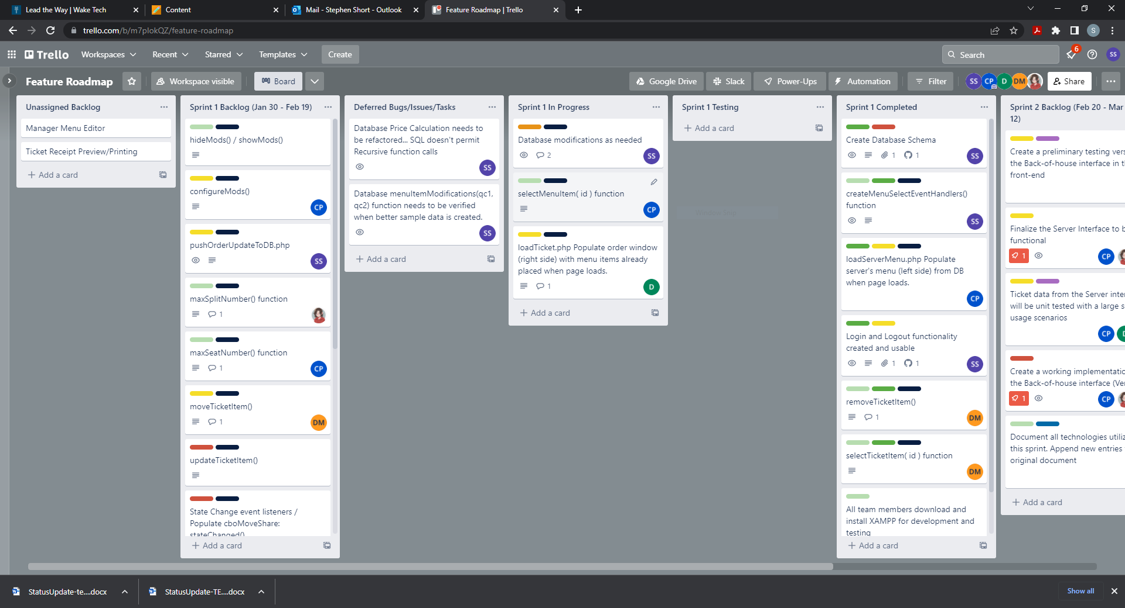

## **STATUS UPDATE DETAILS**

### **Tasks Accomplished**

1. Load Restaurant Menu

2. Add Menu Item to Ticket

3. Basic CSS Styling applied

4. Ticket item can be selected

### **Problems/Challenges (include status – “resolved/not resolved”)**

All listed problems/challenges are currently **unresolved.**

1. Complexity of submitting ticket items. Team is leaning towards using the iframe tag for each ticket item. This will allow for updates from the kitchen without having to refresh the whole page and losing uncommitted ticket items.

2. The menu and ticket panels should overflow vertically with scrollbars. We haven’t found a CSS solution for this yet.

3. DB Implementation of the menu. Each menu item/menu category/customization item/customization category must have a “quickCode” that is manually defined, and must be unique. Carson painstakingly created a code for each object in our test menu.

4. Compatibility with non-desktop devices. Our code uses click. Existing code must be changed to use pointerDown for touch and pen devices.

5. Naming consistency. We are no longer using the words customization and order. Modification and ticket have replaced these words respectively. We are still finding the old words in our code while testing and reviewing.